**Emkan Finance**

Migration

Origination Flow

**Draft2**

**August 17, 2024**

Contents

**Document Version History** 3

**Document Review & Approval History** 3

**Document References** 3

**Introduction** **Error! Bookmark not defined.**

**Scope** **Error! Bookmark not defined.**

**Assumption** **Error! Bookmark not defined.**

**High Level Business Requirements** 4

**Architecture Overview** 5

1. Diagram 5

2. Description 6

**Execution Flow View** 8

.1. Configuration 8

1. Onboarding Flow 9

2. Dashboard Flow 16

3. Loan Eligibility Flow 21

4. KYC **Error! Bookmark not defined.**

5. Create Application and Loan Eligibility check ) 34

6. App Date Entry Flow **Error! Bookmark not defined.**

7. Upload Document Flow 35

8. Loan Offering Flow **Error! Bookmark not defined.**

9. Loan Execution Flow **Error! Bookmark not defined.**

Entity Relation: **Error! Bookmark not defined.**

**Deployment and Security View** 36

Appendix A - Architectural Decisions 36

1. Using IVR as BL before NE **Error! Bookmark not defined.**

1. Using Shedlock to handle schedular **Error! Bookmark not defined.**

Appendix D – Failing Retry Policy 38

Appendix E – Cooling Period 39

Appendix R – Risks 39

Appendix I – General Impacts 39

# **Document Version History**

|  |  |  |  |
| --- | --- | --- | --- |
| **Ver** | **Date** | **Author** | **Change Description** |
| 0.1 | 17/03/2024 | Ishaq | Draft |
| 0.2 | 05/08/2024 | Mohamed Hosni | add work flow diagram  Update Onboarding Flow Diagram  Add create lead diagram  Update CRM diagrams  Add product eligibility Diagram  Add uploads Document Diagram  Update dynamics and Kafka Description |
| 0.3 | 07/08/2024 |  | Add product eligibility Diagram  Add uploads Document Diagram  Update dynamics and Kafka Description |

Table 2 Document Version History

# **Document Review & Approval History**

|  |  |  |  |  |
| --- | --- | --- | --- | --- |
| **Version** | **Reviewer** | **Approver** | **Review Date** | **Approval Date** |
| 0.1 |  |  |  |  |
|  |  |  |  |  |

Table 3 Document Review & Approval History

# **Document References**

|  |  |
| --- | --- |
| **Document Name** | **Document Link** |
|  |  |

**Acronym Defintion**

|  |  |
| --- | --- |
| **Acronym** | **Description** |
| ARB | Al Rajhi Bank |
| API | Application Programming Interface |
| OTP | One Time Password |
| BAU | Business as Usual (already implemented / As is) |
| MS | Microservice |
| AML | Anti-Money Laundering |
| IVR | Interactive Voice Response |
| SAMA | Saudi Central Bank |
| SIMAH | Saudi Credit Bureau |
| MOV | Minimum/Maximum Order Value |

**System Roles**

List of all related systems and their roles as per the solution

|  |  |
| --- | --- |
| **System** | **Role** |
| **Mobile App** | Customer Interface |
| **Emkan Services** | Integration , Business and Mobile BE Services |
| **Kastle** | Loan Orignation Banking System(LOS) has following modules:  Product Catalog  LMS Loan management System |
| **Qarar** | Decision Engine Service[third party], it implements a decision engine based on credit bureau data. it implements decision rules to accept, reject or refer card applications. |
| **DMS** | Document Management System |
| **Unifonic** | Third party for sending notification to customer like SMS or IVR |
| **Emkan NE** | Emkan Notification Engine for sending notification like IVR ,SMS, push notification |
| **Emkan Rule Engine** | System to apply rules provide set of rules result |
| **Newgen** | Loan Origination System |
| **T24** | Loan Management System |
| **Middleware** | Integration Layer |
| **CRM** | Master Customer Data |

# Introduction

Emkan vision is to implement cutting-edge digital lending solutions that can power Emkan's next growth phase. This will be achieved through a phased migration of the existing loan portfolio and implementation of an integrated lending platform.

Key objectives are:

* Completely migrate customer records and loan accounts from Kastle to TRANSACT Core Banking.
* Implement a Newgen LOS to automate end-to-end digital lending workflows for all retail products.

## Document Purpose

The purpose of this document is to produce a High-Level Design (HLD) and architecture for Retail Lending platform implementation and migration, the key building blocks of the solution and how those are going to address the key business and technology requirements. It will also provide the key architectural recommendations and architecture decisions discussed and agreed during the discovery workshops.

## Solution Objectives

* Implement retail products using Newgen LOS and Transact LMS
* Migrate LMS loans accounts and contracts from Kastle to TRANSACT.
* Accelerate the decommissioning of the handicapped legacy core system, impacting time-to-market and stability.
* Mitigate the typical high-risk associated with this strategic initiative.
* Minimal impact on Emkan business and operation.
* Seamless transition through phased retail products data and functional migration.
* Readiness to host new products on the target platform as early as possible.
* Capitalize on Customer-Centricity through enterprise-wide Customer Master.
* Minimal or no impact on customer channels, B2B Gateways and external systems.
* Minimal integration impact on Emkan systems.
* Converge to Emkan new architecture and technology with superior qualities.

## Key Requirements:

LMS Migration Requirements:

* Migrate customer, loan and product data from Kastle to TRANSACT
* Replicate functionalities for loan origination, management and collections
* Interfaces with accounting, reporting, downstream systems
* Role-based access controls and authorization protocols
* Performance, availability, reliability and scalability
* Audit trails and regulatory compliance for the solution

LOS Implementation Requirements:

* End-to-end digital workflows for loan applications
* Configurable approval hierarchies and conditions
* Customizable repayment and settlement options
* Real-time decisioning via underwriting and modeling
* Straight-through processing for majority of applications

# **Scope**

-in scope

The scope of the document covers key architectural viewpoints including business architecture, solution architecture, logical application architecture, data architecture, and technology architecture. The document also captures all the business processes. The HLD provides the definition of the business processes, for Emkan’s Retail Products, solution architecture, logical application architecture, key technology services including integration services, data objects, deployment model. The Integration Team would provide the description of the interfaces proposed in septate IRD, the integration capabilities (messaging, connectivity, transformation, distribution, etc) and the supporting integration formats (XML, JSON, EDI, Bus, File/FTP, DB, etc.).

I

* Build new retail technology platform (LMS & LOS).
* Configure the new LMS on TRANSACT and new LOS on Newgen to cater for the following existing business products:

1. Retail Finance.
2. Micro finance.
3. Top-up.
4. Refinance.
5. Buyout.
6. Auto-lease.
7. Advanced Salary.
8. Direct PF.
9. Credit Card (LOS only).

-out of scope

* Kastle journey out of scope and required changes will covered in separate Document

# **Assumption**

* Emkan Registration flow /Login Flow [BAU]
* Emkan Notification Engine [BAU]

# **High Level Business Requirements**

|  |  |  |
| --- | --- | --- |
| ID | JIRA Ref. | Statement of Requirement |
| 1 |  |  |

The following are the key strategic objectives of the Emkan Fintech Platform, as below:

* A fully- digital Loan Origination and Loan Management service platform that provides services throughout the value chain (loan origination to the disbursement and management)
* A digital platform that offers seamless connectivity with both internal and external systems and is created in accordance with financial industry best practices and standards as per Saudi laws and Emkan’s business model
* An internal loan underwriting capacity and approval/rejection capacity, that is fully automated and highly optimized, with improved support for Analytics based on rules engine for decision making as per B2B inputs
* Highly configurable workflows to serve the needs of different Loan products, offered by Emkan Finance
* Enabling end to end security to ensure the privacy and confidentiality of the customer’s data and Realtime customer data with CRM
* Customer onboarding- Customer registration or login
* Loan application- Customer selects a particular Loan product start application from Emkan channel.
* Loan eligibility and Contract sign- Customer due diligence, and eligibility based on Credit reports, income and monthly liabilities, with contract sign customer.
* Disbursement and Loan Management- Payment to customer and account and manage the further updates on monthly payments by customer, till last payment and contract closure in addition to loan early repayment, pas due management, loan amendment.
* Collection- Update collection management system, for regular or defaulted payments daily.

**Drops :**

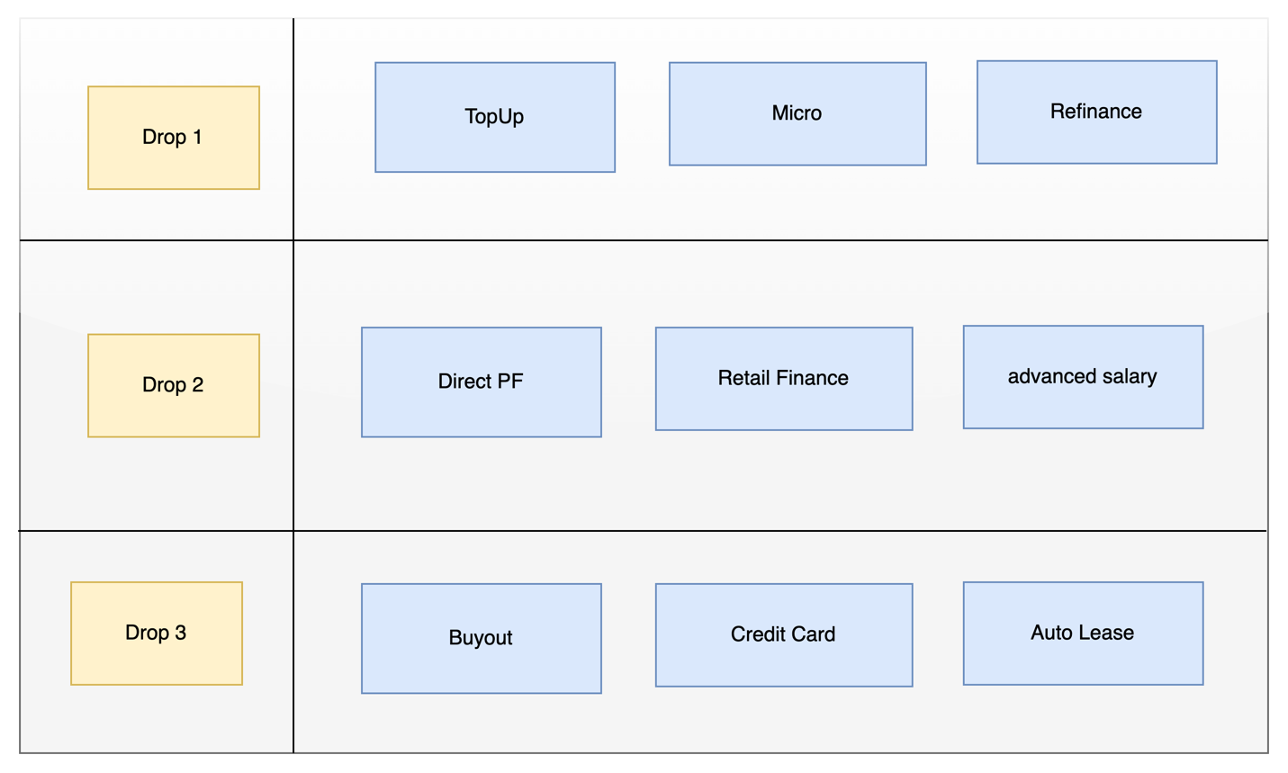

**Risks on Defined Drops:**

1. **Customer will not be able to refinance Direct PF Applications**
2. **If customer is eligible for direct PF and he apply on topup or micro Qarar should disable offering Direct PF and vice versa**

**Recommendation**

1. **Moving Direct PF to Drop 1**
2. **Adding functionality to allow customer to apply for specific product if this product is QARAR decision is other product**

# **Architecture Overview**

Our architecture will be Mix of the following:

* Cloud based Architecture using OCI
* Microservice Architecture
* Service Oriented Architecture
* Event Driven Architecture

### Architecture Layers

1. Channel
2. External Gateway
3. User Repository and Identity Management
4. Back-end For Front-end (BFF)
5. Integration Layer and internal API Gateway
6. Core Systems
7. Data Layer

## Diagram

The below diagram will show how the architecture will be

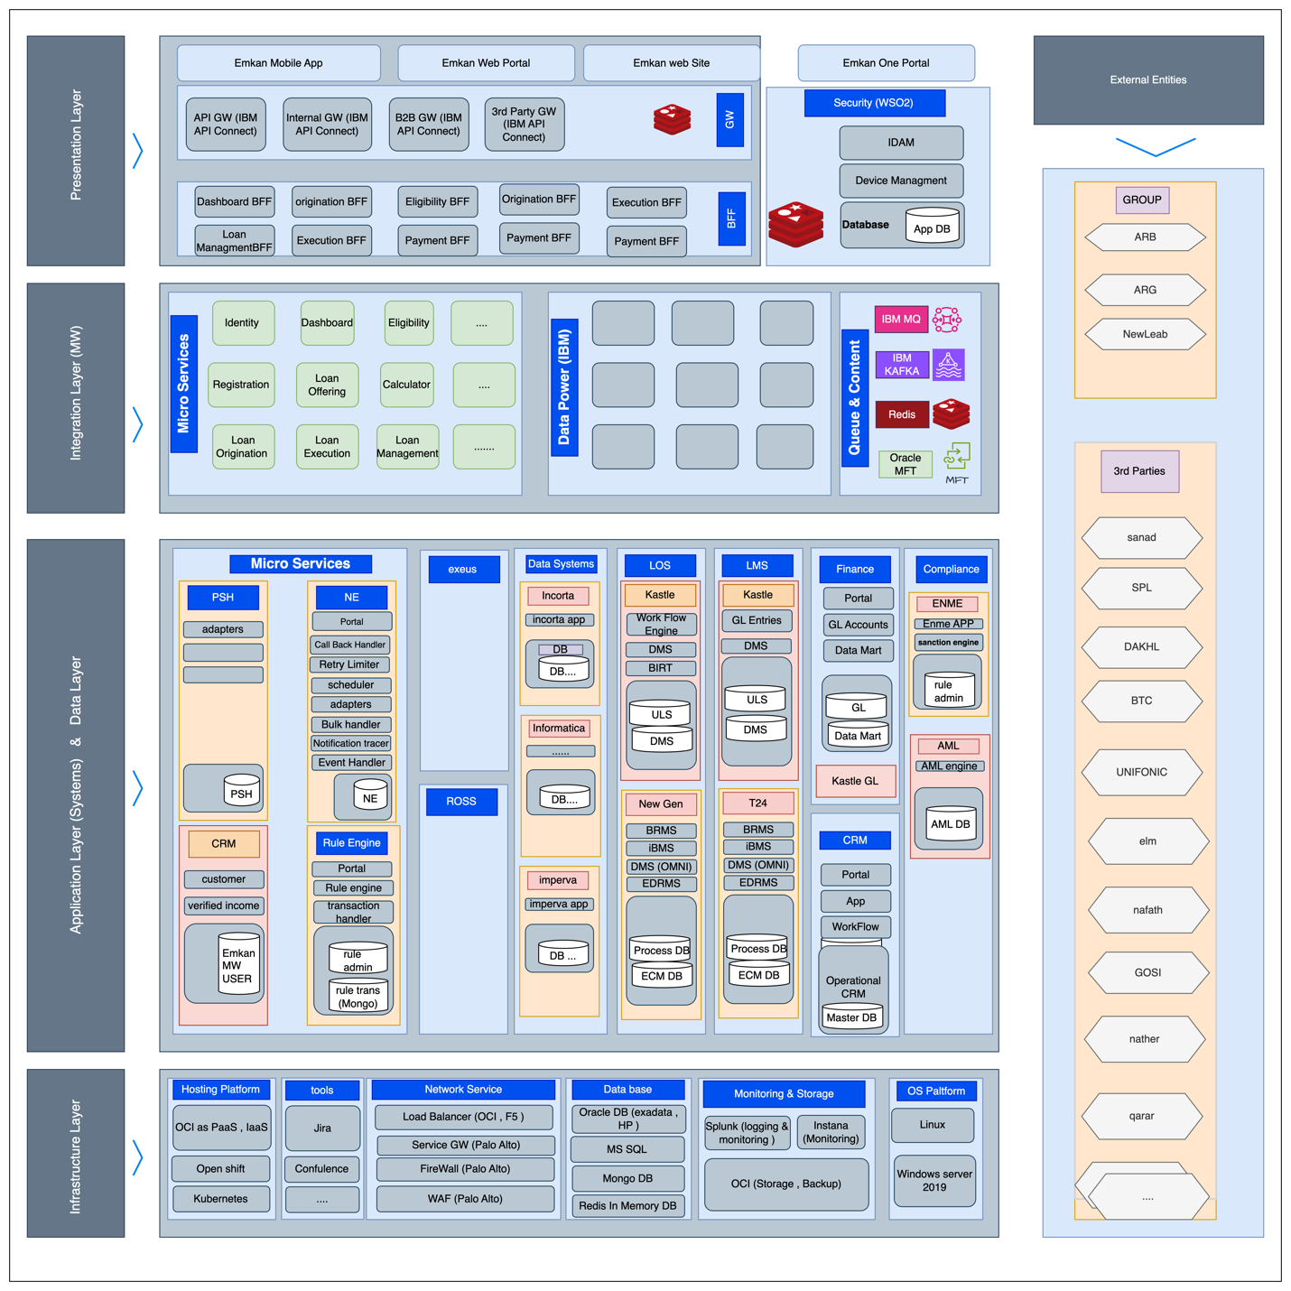

|  |  |  |
| --- | --- | --- |
|  | Name | Description |
| Channels | | |
| 1 | Mobile Applications | Emkan Mobile Application |
| 2 | Emkan’s web site | Emkan Mobile Application (Retail Finance RF) |
| 3 | Kastle Back office | Branch journey and underwriting tasks |
| 4 | Newgen Back office | and underwriting tasks |
| 5 | Transact Back Office | LMS back-office tasks |
| 6 | One Portal | Emkan one portal Staff portal |
| 7 | Emkan’s Merchants Portal | Emkan merchant portal |
| 8 | Merchant’s E-commerce Platforms | Like Apple or Jarir |
| 9 | Emkan Branch | Newgen Branch journey |
| Internal Systems and Core Backends | | |
| 1 | Temenos Transact | LMS Core Banking |
| 2 | iBPS | Newgen LOS |
| 3 | Kastle ULS | Kastle unified loan system |
| 4 | MS Dynamics | CRM |
| 5 | Oracle GL | GL |
| 6 | Oracle MFT | Secured file transfer |
| 7 | ENME | Sanction |
| 8 | SAS | Provisioning |
| 9 | Exus | Collection |
| LOS External 3rd Parties | | |
| 1 | GOSI | None government employee income details |
| 2 | Dakhli | government employee income details |
| 3 | Saudi Post SPL | All the National address record of the customer |
| 4 | Qarar | Qarar is credit decision and limit engine fetch and evaluates the customer cedit report from SIMH and provides the scoring, rating, rule-based pricing and decision (accept, reject or refer) |
| 5 | Unifonic | sending notification (SMS, IVR) |
| 6 | Emdha | Digital Signature service |
| 7 | DDCAP | This service is to be triggered for purchase/sale of commodity as per Sharia Law |
| 8 | Sanad-Nafith | Promissory Note- Nafith Platform, approves and certifies the promissory note and as the final step the promissory note is saved for future reference |
| 9 | Nafath | National single sign on and Absher details |
| 10 | Elm | sending OTP /getting Absher details, verify mobile ownership |
| 11 | ARB-Channel | Al-Rajhi Bank provides the information for if the customer is an ARB customer and its Account information, IBAN verification |
| 12 | Saudi Payment | IBAN verification for none ARB customers |
|  |  |  |
|  |  |  |
| LMS External 3rd Parties | | |
| 1 | Neolep PGW | Ccustomer payment |
| 2 | ARB-Mokafaa | ARB Loyalty program |
| 3 | SIMAH | SIMAH file as part of compliance |
| 4 | Natheer | Natheer watch list |
| 5 | ARB-DD | ARB direct deduction file |
| 6 | Nafith | Cancel promissory note |
| 7 | MOJ Najez | Capture Court Case ID |

Integration layers

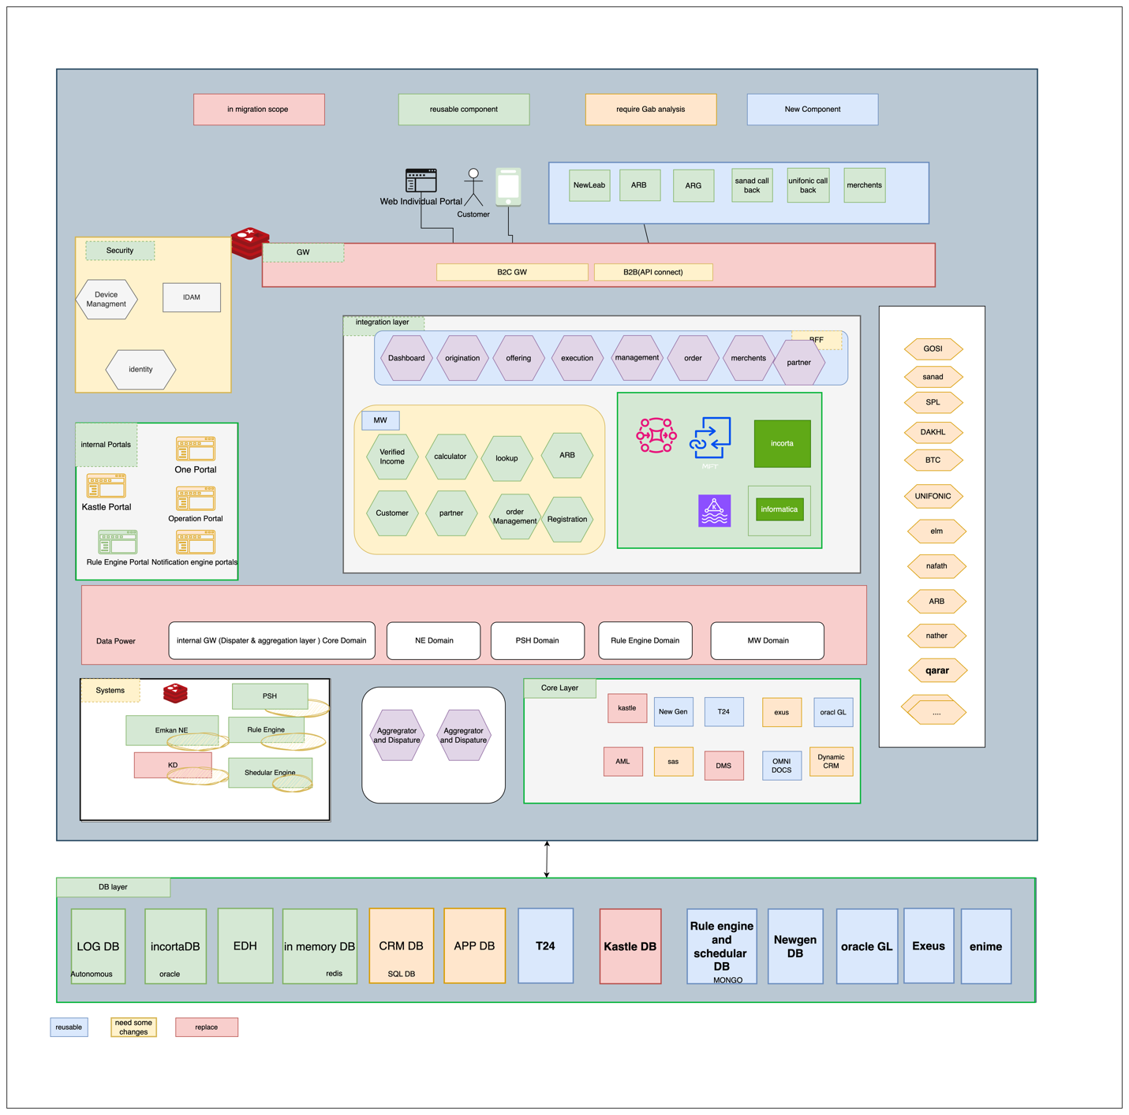

GWs Integration

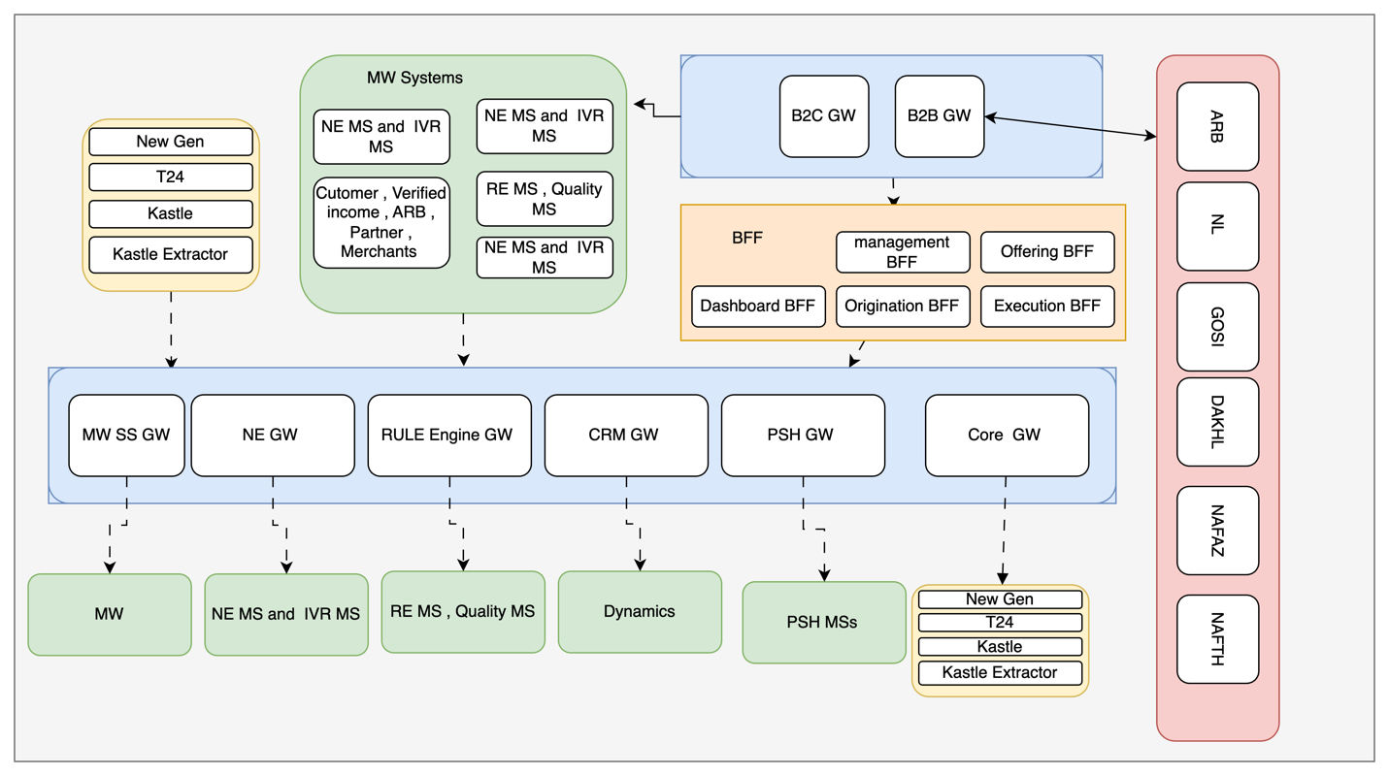

|  |  |  |  |  |
| --- | --- | --- | --- | --- |
| **System** | **Internal DataPower** | **Vendor Name** | | **IBM** |
| **Description** | IBM internal API Gateway Appliance | | | |
| **Infrastructure** | OCI | **Deployment** | OpenShift containers | |
| **Endpoints Exposed** | | | | |
| **Transact Endpoints** | Mobile and web customer inbound traffic | **Kastle Endpoints** | Integration with merchants’ platform inbound traffic | |
| **Newgen iBPS Endpoints** | Mobile and web customer outbound traffic | **Others** |  | |

## Integration Tools and Systems

The integration layer offers other tools and systems for integration

### Apache Kafka

### IBM MQ

### Informatica ETL

### Oracle MFT

### Incorta

## Core Systems

Figure 16 Core Backends

|  |  |  |
| --- | --- | --- |
| **Core Backends** | | |
| **1** | Temenos Transact | LMS |
| **2** | Newgen iBPs | LOS |
| **3** | Kastle | ULS |
| **4** | MS Dynamics | CRM |
| **5** | Oracle GL | GL |
| **6** | ENME | Sanction |
| **7** | Exus | Collection |
| **8** | Emkan Payment System Hub PSH | Payment MS |
| **9** | Emkan Notification Engine | Notification engine |
| **10** | Emkan Rules Engine | Rule engine |
| **11** | SAS | Provisioning |

## Logical Application Architecture

Figure 17 LOS,LMS,CRM AND ENME LOGICAL ARCHTECTURE

### 1-Transact Loan Management System (LMS)

|  |  |  |  |  |
| --- | --- | --- | --- | --- |
| **System** | **Transact** | **Vendor Name** | | **Temenos** |
| **Description** | Core Banking system by Temenos used to manage LMS | | | |
| **Infrastructure** | OCI | **Deployment** | Containerization | |
| **Container Orchestrator** | OpenShift | **Release** | R22 | |
| **System Components** | | | | |
| **Transact Core** | LMS Core Banking | **Temenos Data Hub** | Analytics and reporting platform | |
| **Transact Backoffice** | Transact user interface for operation team | **Data Event Streaming DES** | Event streaming component capturing real-time transactions | |
| **IRIS Framework** | API Framework |  |  | |

### 2-Newgen iBPS LOS

|  |  |  |  |  |
| --- | --- | --- | --- | --- |
| **System** | **Transact** | **Vendor Name** | | **Temenos** |
| **Description** | Core Banking system by Temenos used to manage LMS | | | |
| **Infrastructure** | OCI | **Deployment** | Virtual machines | |
| **Container Orchestrator** | N/A | **Release** | xxx | |
| **System Components** | | | | |
| **iBPS** | Process engine and application server | **BRMS** | rule engine (will not be used for retail products however it is in use for SME, BNPL and Apple | |
| **OmniDocs** | DMS |  |  | |

### 3- MS-Dynamics

|  |  |  |  |  |
| --- | --- | --- | --- | --- |
| **System** | **MS Dynamics** | **Vendor Name** | | **Microsoft** |
| **Description** | CRM System | | | |
| **Infrastructure** | OCI | **Deployment** | Virtual machines | |
| **Container Orchestrator** | N/A | **Release** | xxx | |
| **System Components** | | | | |
| **Front-End** | Web based front-end for operation and administration teams | **Back-end App** | Core CRM Logic | |
| **Integration services** | API layer |  |  | |

### 4- ENME

|  |  |  |  |  |
| --- | --- | --- | --- | --- |
| **System** | **ENME** | **Vendor Name** | | **EJADA** |
| **Description** | Sanction, screening and Customer Rating | | | |
| **Infrastructure** | OCI | **Deployment** | Virtual machines | |
| **Container Orchestrator** | N/A | **Release** | xxx | |
| **System Components** | | | | |
| **ENME Front-end** | Web based front-end for operation and administration teams | **Screening engine** | Sanction and screening engine | |

|  |  |  |  |  |
| --- | --- | --- | --- | --- |
| **System** | **Transact** | **Vendor Name** | | **Temenos** |
| **Description** | Core Banking system by Temenos used to manage LMS | | | |
| **Infrastructure** | OCI | **Deployment** | Containerization | |
| **Container Orchestrator** | OpenShift | **Release** | R22 | |
| **System Components** | | | | |
| **Transact Core** | LMS Core Banking | **Temenos Data Hub** | Analytics and reporting platform | |
| **Transact Backoffice** | Transact user interface for operation team | **Data Event Streaming DES** | Event streaming component capturing real-time transactions | |
| **IRIS Framework** | API Framework |  |  | |

### 2-Newgen iBPS LOS

|  |  |  |  |  |
| --- | --- | --- | --- | --- |
| **System** | **Transact** | **Vendor Name** | | **Temenos** |
| **Description** | Core Banking system by Temenos used to manage LMS | | | |
| **Infrastructure** | OCI | **Deployment** | Virtual machines | |
| **Container Orchestrator** | N/A | **Release** | xxx | |
| **System Components** | | | | |
| **iBPS** | Process engine and application server | **BRMS** | rule engine (will not be used for retail products however it is in use for SME, BNPL and Apple | |
| **OmniDocs** | DMS |  |  | |

### 3- MS-Dynamics

|  |  |  |  |  |
| --- | --- | --- | --- | --- |
| **System** | **MS Dynamics** | **Vendor Name** | | **Microsoft** |
| **Description** | CRM System | | | |
| **Infrastructure** | OCI | **Deployment** | Virtual machines | |
| **Container Orchestrator** | N/A | **Release** | xxx | |
| **System Components** | | | | |
| **Front-End** | Web based front-end for operation and administration teams | **Back-end App** | Core CRM Logic | |
| **Integration services** | API layer |  |  | |

### 4- ENME

|  |  |  |  |  |
| --- | --- | --- | --- | --- |
| **System** | **ENME** | **Vendor Name** | | **EJADA** |
| **Description** | Sanction, screening and Customer Rating | | | |
| **Infrastructure** | OCI | **Deployment** | Virtual machines | |
| **Container Orchestrator** | N/A | **Release** | xxx | |
| **System Components** | | | | |
| **ENME Front-end** | Web based front-end for operation and administration teams | **Screening engine** | Sanction and screening engine | |

### 1- Emkan Payment System Hub (PSH)

|  |  |  |  |  |
| --- | --- | --- | --- | --- |
| **System** | **Emkan Payment System Hub** | **Vendor Name** | | **Emkan** |
| **Description** | Payment system receive online payment from different sources and reflect it to core systems | | | |
| **Infrastructure** | OCI | **Deployment** | Containerization | |
| **Container Orchestrator** | Kubernetes | **Release** | N/A | |
| **System Components** | | | | |
| **Transact Dispatcher** | Reflects payment to Transact | **Kastle Dispatcher** | Reflects payment to Kastle | |
| **Cortex Dispatcher** | Reflects payment to cortex |  |  | |

### 2- Emkan Notification Engine

|  |  |  |  |  |
| --- | --- | --- | --- | --- |
| **System** | **Emkan Notification Engine** | **Vendor Name** | | **Emkan** |
| **Description** | Handle multiple type of notifications sent across the system | | | |
| **Infrastructure** | OCI | **Deployment** | Containerization | |
| **Container Orchestrator** | Kubernetes | **Release** | N/A | |

### 3- Emkan Rules Engine

|  |  |  |  |  |
| --- | --- | --- | --- | --- |
| **System** | **Emkan Rules Engine** | **Vendor Name** | | **Emkan** |
| **Description** | Rules engine offer friendly user interface used by Emkan Business Team to define different product eligibility rules | | | |
| **Infrastructure** | OCI | **Deployment** | Containerization | |
| **Container Orchestrator** | Kubernetes | **Release** | N/A | |

### 6- Registration Microservice

|  |  |  |  |  |
| --- | --- | --- | --- | --- |
| **System** | **Emkan Rules Engine** | **Vendor Name** | | **Emkan** |
| **Description** | Handle customer onboarding and integrate with SPL | | | |
| **Infrastructure** | OCI | **Deployment** | Containerization | |
| **Container Orchestrator** | Kubernetes | **Release** | N/A | |

## Parallel Run and Coexistence

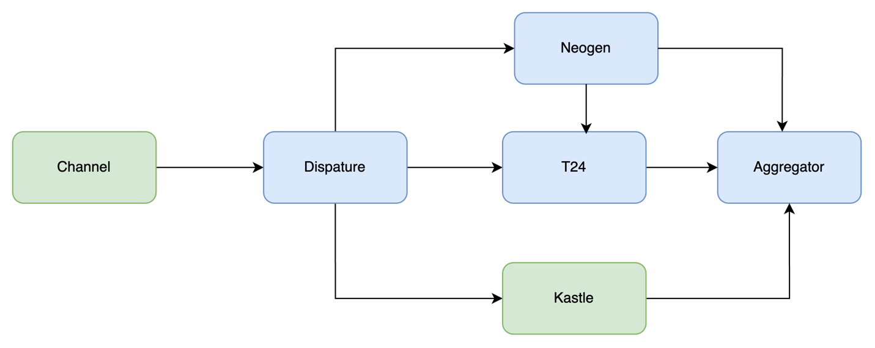

The migration project will be carried out as a series of drops each of them will have a group of Emkan’s Retail products. Business availability and continuity is a must.

During the project Emkan’s Retail Products Portfolio will be as the following:

* 1. Products not migrated and it will be availed through the Kastle stack
  2. Products migrated availed through the Newgen, Transact stack.
  3. Applications started and not completed before their products moved to the new technology stack at cutoff time will continue old stack until Loan contracts are created and will be migrated to new stack as delta migration

### Inquiries:

1. none migrated Products Inquires will be executed and fetched from old stack.
2. migrated Products Inquires will be executed and fetched from new stack.

To achieve these requirements two components would be implemented inside IBM integration layer

### 1-Aggregator Logic

Integration layer will handle the coexistence aggregation logic by consuming Kastle (LOS& LMS) endpoints and Transact and Newgen endpoints related to

* Dashboard (to retrieve active contracts and ongoing applications from different systems )
* Active and ongoing application on both system

For more details you can refer to execution flow

### 2-Dispatcher Logic

Mobile will call new APIs exposed on B2C GW and will reach to new stack

## Description

|  |  |  |
| --- | --- | --- |
| **Layer** | **Service/component** | **Role** |
| **Channels** | Staff | One Portal, Core Systems |
|  | Customer | Emkan Mobile App, Website |
|  | Partners | Merchant Portal, Merchant E-Commerce Platform |
| **Gateway** | B2C  IBM DataPower | Receiving traffic from Channel Customer |
| B2B Gateway | Receiving traffic from Channel Partners |
| IG | Receiving traffic from BFF and Middleware Integration Microservice layer |
| TPP Gateway | To And Fro traffic of Third Party Providers |
| Dashboard | MS for doing transformation , aggregation,segregation ,... related to application dashboard communications like fetching all applications within stattistics from different core banking system,... |
| **Security** | IDAM(WSO2) | Identity Server for  identity and access management, |
| Identity Service | MS for identifying user [authentication/authorization] |
| Device Management | MS for managing registered device of customer |
| **Support Services** | Emkan NE | Notification Engine for sending notification like SMS,IVR, push Notification Message and feeback caller |
| Emkan Scheduler Engine | Scheduler Engine to Handling Job Tasks for Emkan |
| Emkan Rule Engine | Rule Engine to apply Ruel Sets |

# **Execution Flow View**

# Configuration

* + 1. **New Gen Configuration**:
* Configure below stage as unified stages for all products

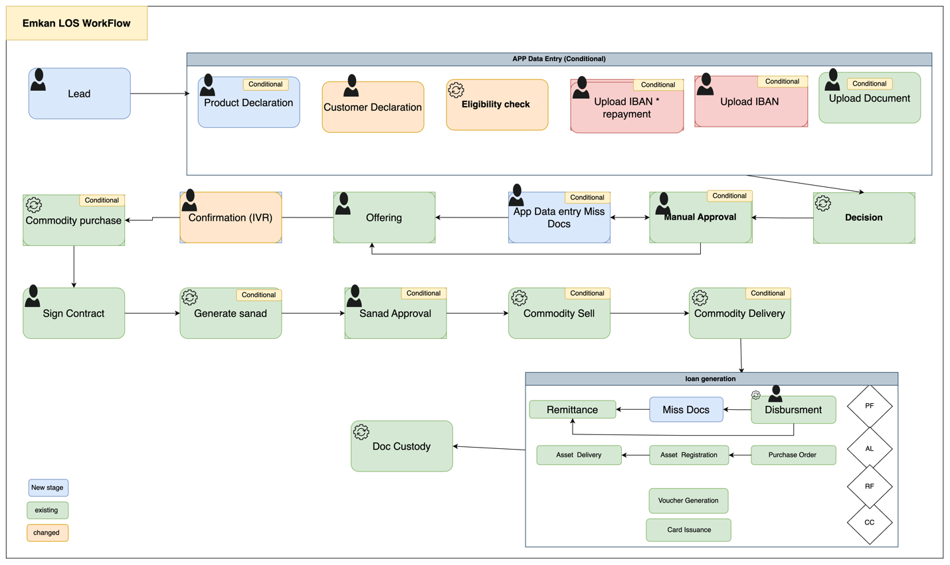

Description:

|  |  |  |
| --- | --- | --- |
|  | **Task Name** | **Description** |
| LEAD | | - Generating Unique identifier refer to Process-ID or Parent Application ID  - Applying loan eligibility rules  - Checking customer sanction and screening |
| App Data Entry | Customer declaration | Customer need to submit all expense, obligations ,income ,employer info , IBAN |
| Product Eligibility check | Generate application[loans] per item |
| Repayment Mode | Set repayment mode for customer |
| Upload Document | Customer submit document required |
| Decision | | Final decision and final offer if accepted |
| Manual Approval | | Move application to underwrite (L1-L9 ) for manual check |
| Miss Document | | Ask customer to upload missed Document |
| Customer Offering Approval | | Customer decides accept or reject final offer |
| Confirmation stage [IVR] | | Triggering IVR call for loan confirmation |
| Commodity purchase maker | | Purchasing commodity |
| Sign contract | | Customer accept /reject Sign contract of all applications |
| Generate Sanad | | System generates PN for customer |
| Sanad Approval | | Customer decides accept or reject Sanad |
| Commodity sell maker | | Selling commodity |
| Disbursement | | Disbursement Stage |
| Remittance | | Remittance Stage |
| Document custody | | Complete of process |

# Onboarding Flow

1. Diagram

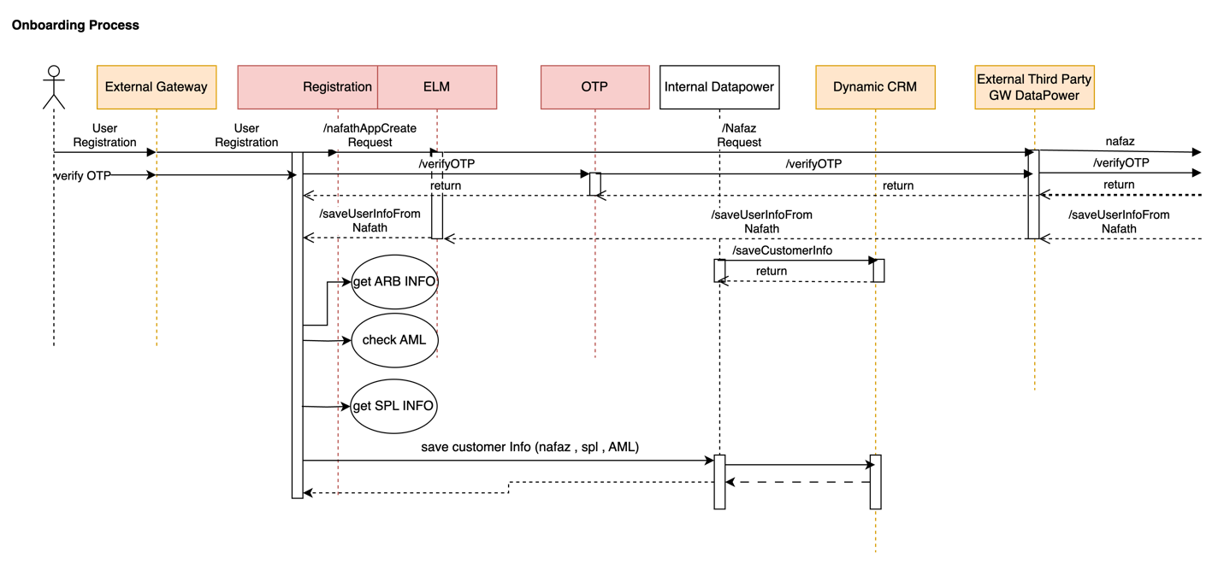

|  |  |  |  |  |  |
| --- | --- | --- | --- | --- | --- |
| **System Provider** | **Action** | **Request** | **Response** | **Type** | **Description** |
| Nafath | /nafathAppCreateRequest | asIs | asIs |  |  |
| OTP | /verifyOTP | asIs | asIs |  |  |
| Registration | /saveUserInfoFromNafath | asIs | asIs |  |  |
| **CRM** | /saveCustomerInfo |  |  |  | Refer IRD  CRM-EMK-DIG001  This api will be exposed by CRM to emkan. Emkan will call this api to save customer related information in Dynamic CRM.  Below objects will be passed as part of this request.  "basicCustInfo","addInfo","salInfo","expInfo","empInfo","autoLeaseCustomerInfo",ibanInfo","buyOutInfo","naInfo","companyInfo","loanDetails"  If any object is null then that information will not be saved in Dynamic CRM. |
| **CRM** | /getCustomerInfo |  |  |  | Refer IRD  CRM-EMK-DIG001  This api will be exposed by CRM to emkan. Emkan will call this api to get customer profile information from Dynamic CRM.  Below objects will be passed as part of this request to fetch customer profile.  "basicCustInfo","addInfo","salInfo","expInfo","empInfo","autoLeaseCustomerInfo","arbAccounts","ibanInfo","buyOutInfo","naInfo","companyInfo","loanDetails"  Objects for which information is not required it should be passed as null. |
| **CRM** | /updateCustomerInfo |  |  |  | Refer IRD  CRM-EMK-DIG001  This api will be exposed by CRM to emkan. Emkan will call /saveCustomerInfo api to update customer profile information in Dynamic CRM.  Any object which need no update will be passed as null.  Below objects will be passed as part of this request to update customer information.  "basicCustInfo","addInfo","salInfo","expInfo","empInfo","autoLeaseCustomerInfo","arbAccounts","ibanInfo","buyOutInfo","naInfo","companyInfo","loanDetails" |
| ARB | /getARBInfo | asIs | asIs |  |  |
| ENME | CheckAML |  |  |  | Refer LOAN-EMK-DIG003 for api Specifications.  Call ENME to verify customer screening process.  Modify AML URL to ENME URL. |
| Newgen | /createCustomer |  |  |  | Refer LOAN-EMK-DIG005 for API Specifications.  Call Newgen to create Customer. |

* 1. – branch flow

1. 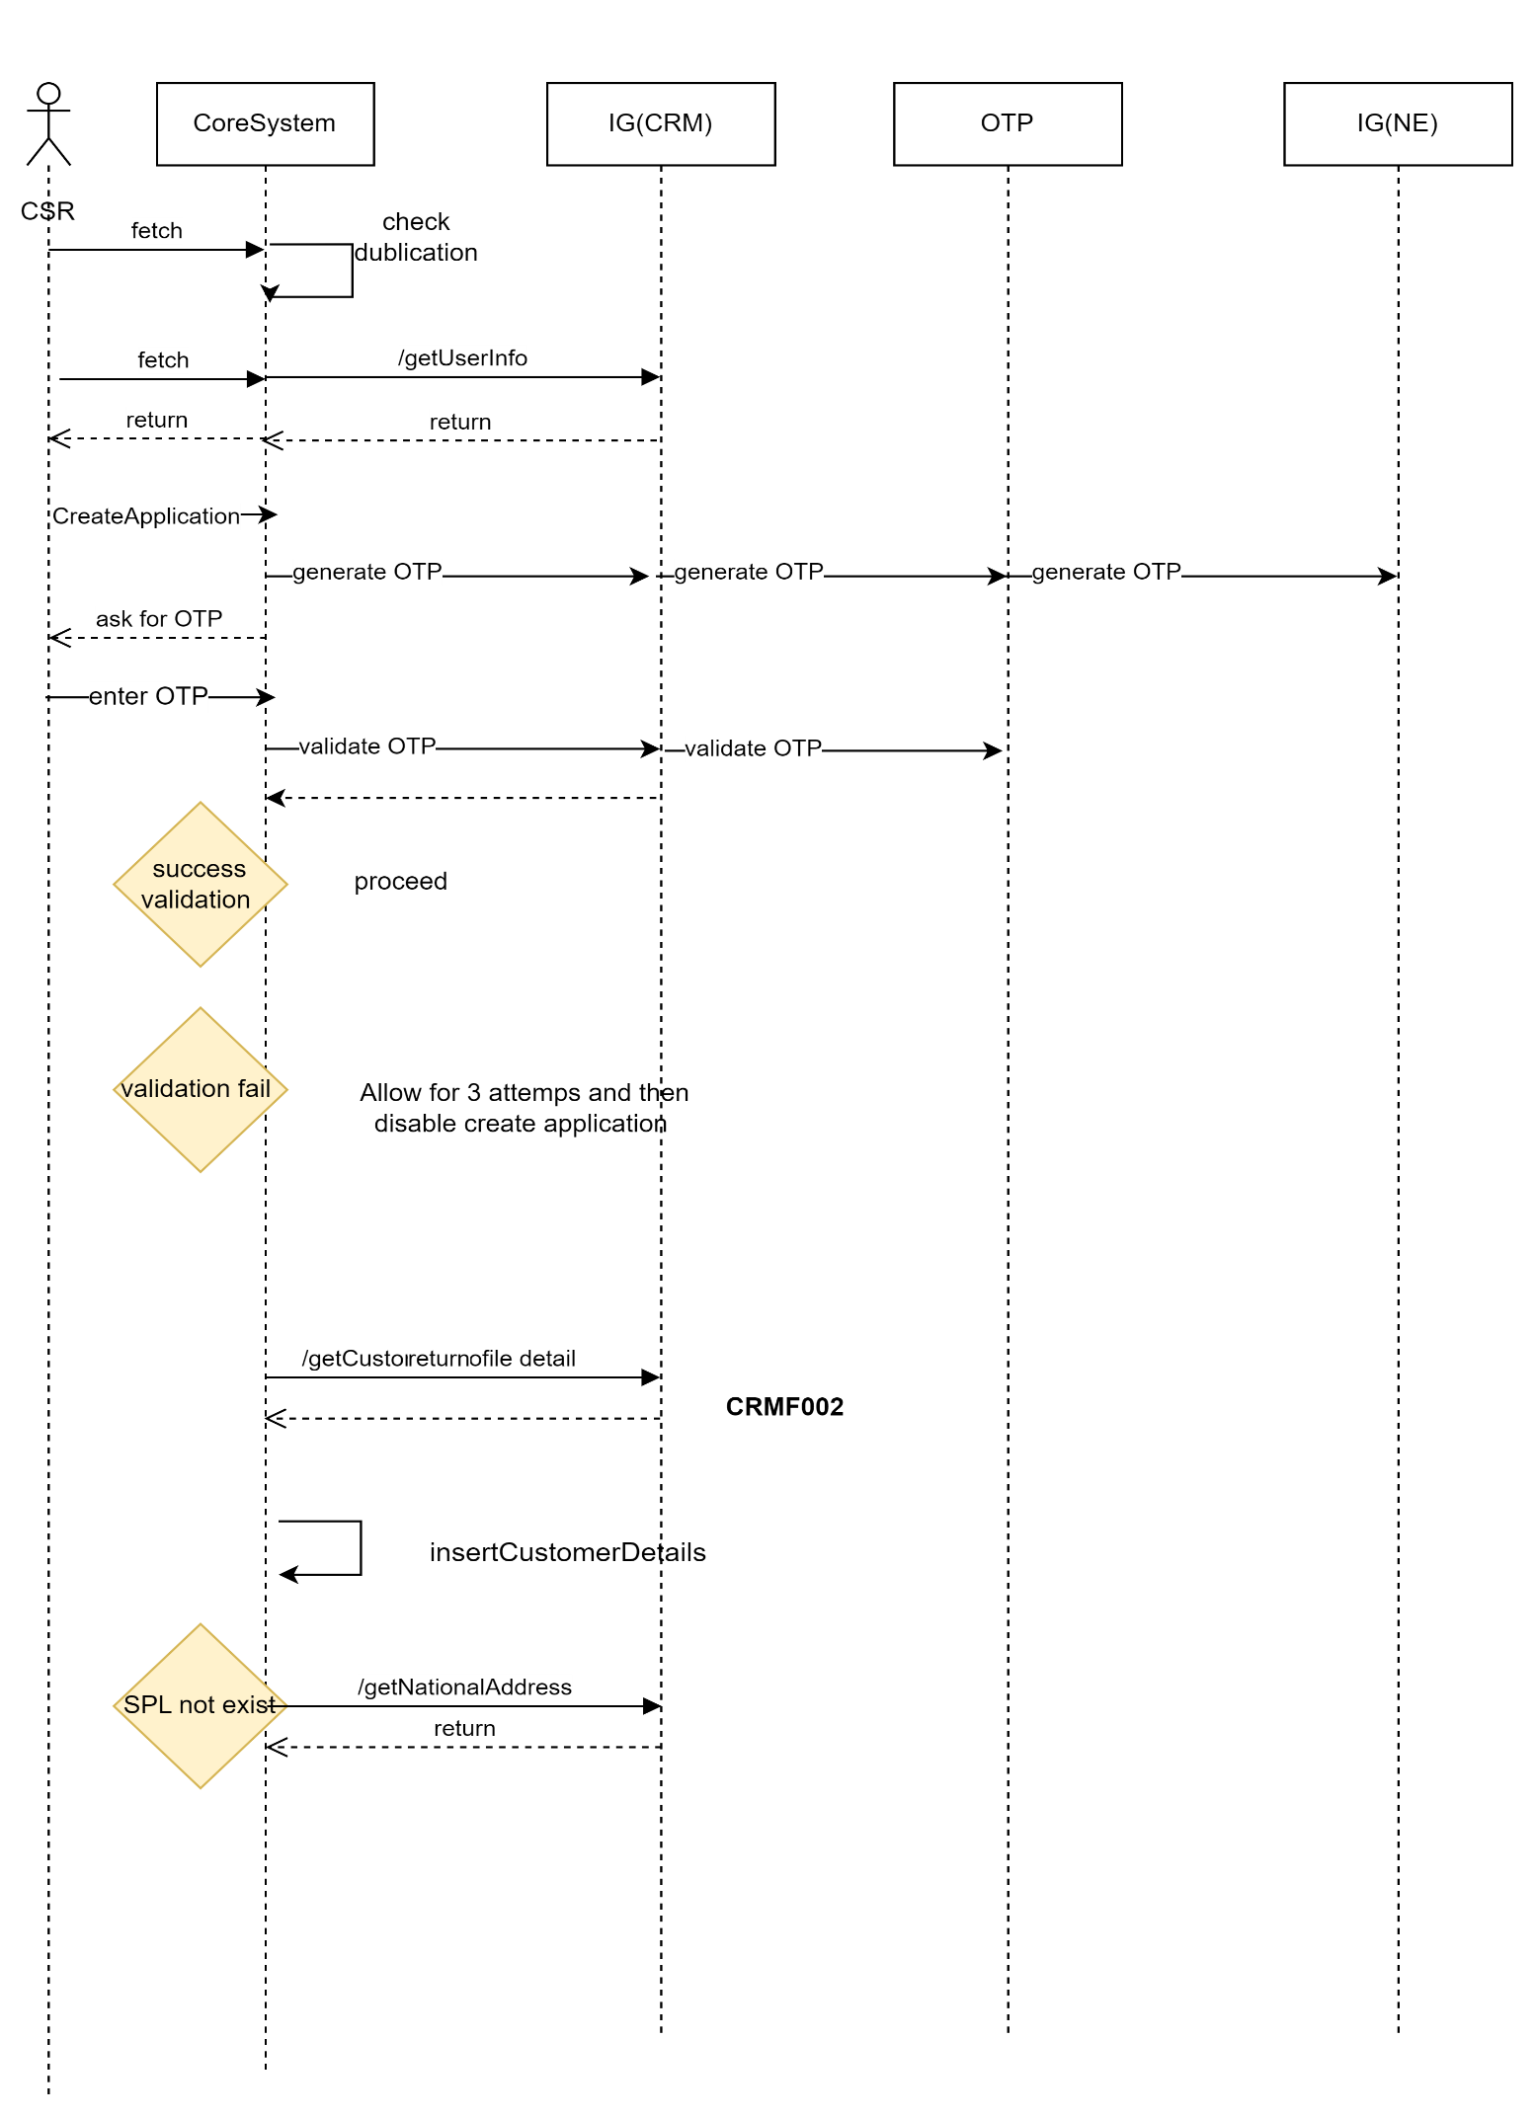
2. Description

|  |  |  |  |  |  |
| --- | --- | --- | --- | --- | --- |
| **System Provider** | **Action** | **Request** | **Response** | **Type** | **Description** |
| Core | /getUserInfo | asIs | asIs |  | If user is registering for first time from branch then call Yakeen and insert information into Emkan_Customer table.  While user registers from Mobile then update Nafath information into Emkan_Customer table. |
| Core | createApplication | asIs | asIs |  | Call Newgen system to create the application |
| OTP | /verifyOTP | asIs | asIs |  |  |
| Customer | /getCustomerProfileDetails | asIs |  |  | This will internally calls /getCustomerInfo to fetch the information from CRM DB. |
| **CRM** | /saveCustomerInfo |  |  |  | Refer IRD  CRM-EMK-DIG001  This api will be exposed by CRM to emkan. Emkan will call this api to save customer related information in Dynamic CRM.  Below objects will be passed as part of this request.  "basicCustInfo","addInfo","salInfo","expInfo","empInfo","autoLeaseCustomerInfo",ibanInfo","buyOutInfo","naInfo","companyInfo","loanDetails"  If any object is null then that information will not be saved in Dynamic CRM. |
| **CRM** | /getCustomerInfo |  |  |  | Refer IRD  CRM-EMK-DIG001  This api will be exposed by CRM to emkan. Emkan will call this api to get customer profile information from Dynamic CRM.  Below objects will be passed as part of this request to fetch customer profile.  "basicCustInfo","addInfo","salInfo","expInfo","empInfo","autoLeaseCustomerInfo","arbAccounts","ibanInfo","buyOutInfo","naInfo","companyInfo","loanDetails" |
| **CRM** | /saveCustomerInfo |  |  |  | Refer IRD  CRM-EMK-DIG001  This api will be exposed by CRM to emkan. Emkan will call this api to update customer profile information in Dynamic CRM.  Any object which need no update will be passed as null.  Below objects will be passed as part of this request to update customer information.  "basicCustInfo","addInfo","salInfo","expInfo","empInfo","autoLeaseCustomerInfo","arbAccounts","ibanInfo","buyOutInfo","naInfo","companyInfo","loanDetails" |
| Customer | /getUserInfo | asIs | asIs |  |  |
| OTP | /sendEmkanOTP | asIs | asIs |  |  |
| NationalAddress | /getNationalAddress | asIs | asIs |  | If user is in nationaladdress cooling period then fetch information from Dynamic CRM  If cooling period is off then fetch information from Saudi Post. |

# Dashboard Flow

1. Diagram

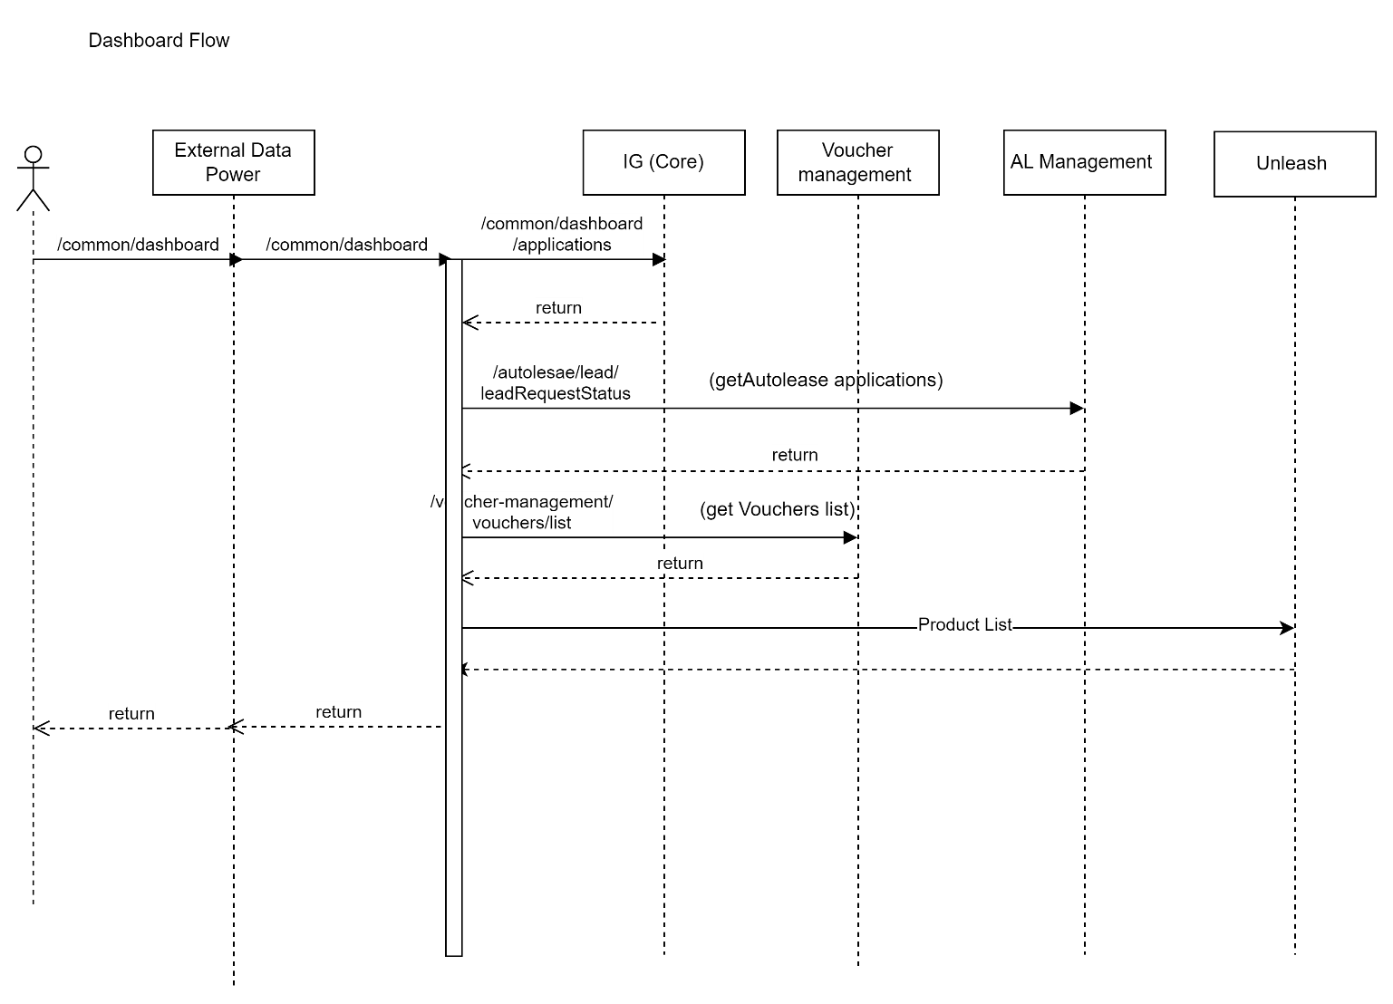

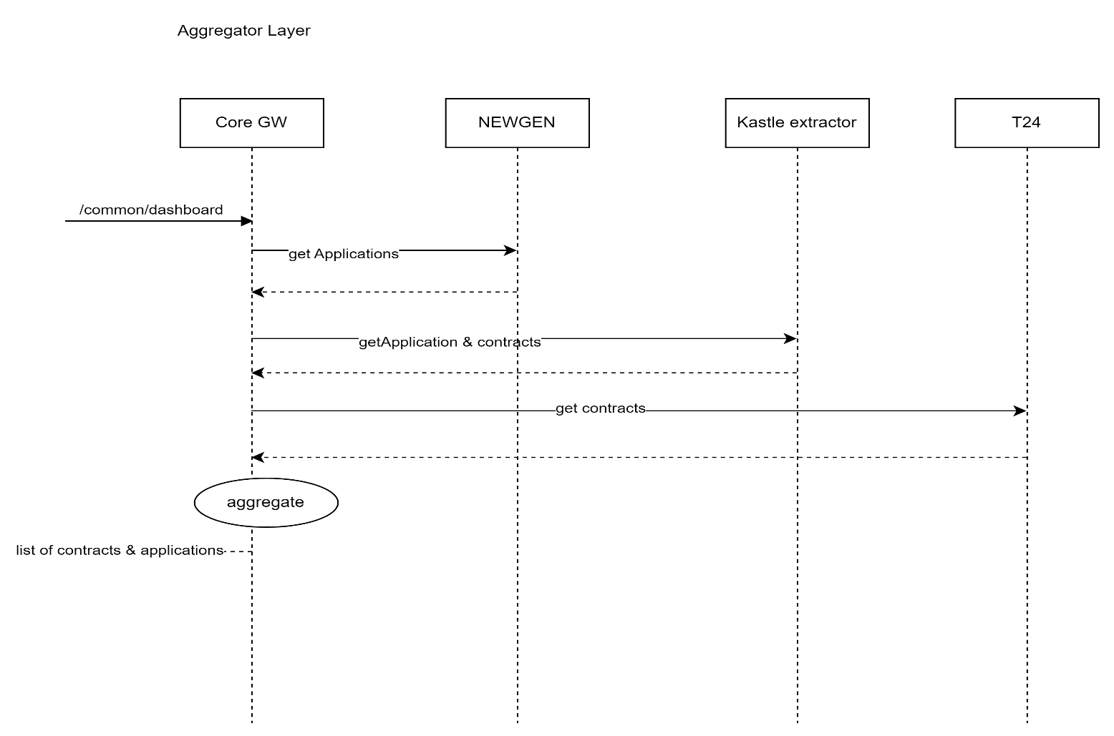

Description:

|  |  |  |  |  |  |
| --- | --- | --- | --- | --- | --- |
| **System Provider** | **Action** | **Request** | **Response** | **Type** | **Description** |
| Dashboard | /common/dashboard | {  "status": "active",  "cifId": "CIF789456",  "nationalId": "NID123456789"  } | {  "id": 123456,  "applicationId": "APP001",  "lastInstallmentDate": "2024-07-15",  "subProduct": "SubProduct A",  "product": "Product A",  "installmentAmount": 500.00,  "stage": "In Progress",  "totalFinancedAmount": 10000.00,  "amountRemaining": 3000.00,  "nextInstallmentDue": "2024-08-15",  "loannumber": "LN123456789",  "status": "active",  "substage": "Underwriting",  "subsourcingChannel": "Online",  "bp": "BP123",  "source": "Web",  "installmentRemainDuration": 5,  "remainingInstallmentNumber": "5",  "reasonCode": "RC001",  "reasonMessage": "Payment overdue",  "reasons": [  {  "reasonCode": "RC001",  "reasonmsg": "Payment overdue"  },  {  "reasonCode": "RC002",  "reasonmsg": "Insufficient funds"  }  ]  } |  | Instead of calling Kastle-Extractor call Integration Layer(Internal Data power) end point which will aggregate response from T24/Kastle/Newgen and send all applications. |
| Autolease | /leadRequestStatus | asIs | asIs |  |  |
| Voucher-Management | /vocucherList | asIs | asIs |  |  |

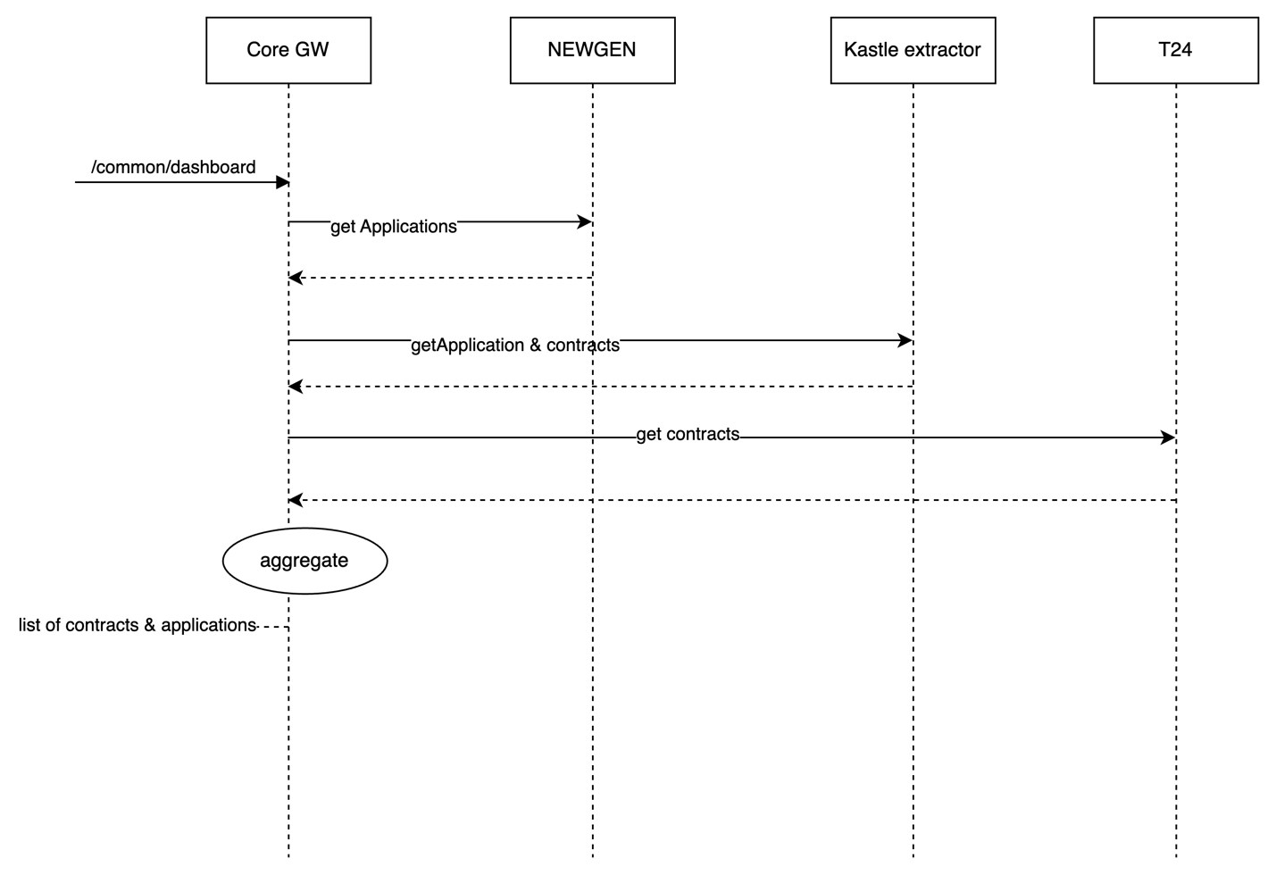

# Loan Eligibility Flow (Lead Generation Flow )

* Diagram

Description:

|  |  |  |  |  |  |
| --- | --- | --- | --- | --- | --- |
| **System Provider** | **Action** | **Request** | **Response** | **Type** | **Description** |
| Customer | /getCustomerProfileDetails | asIs | asIs |  | This will internally calls /getCustomerInfo to fetch the information from CRM DB. |
| **CRM** | /getCustomerInfo |  |  |  | Refer IRD  CRM-EMK-DIG001  This api will be exposed by CRM to emkan. Emkan will call this api to get customer profile information from Dynamic CRM.  Below objects will be passed as part of this request to fetch customer profile.  "basicCustInfo","addInfo","salInfo","expInfo","empInfo","autoLeaseCustomerInfo","arbAccounts","ibanInfo","buyOutInfo","naInfo","companyInfo","loanDetails" |

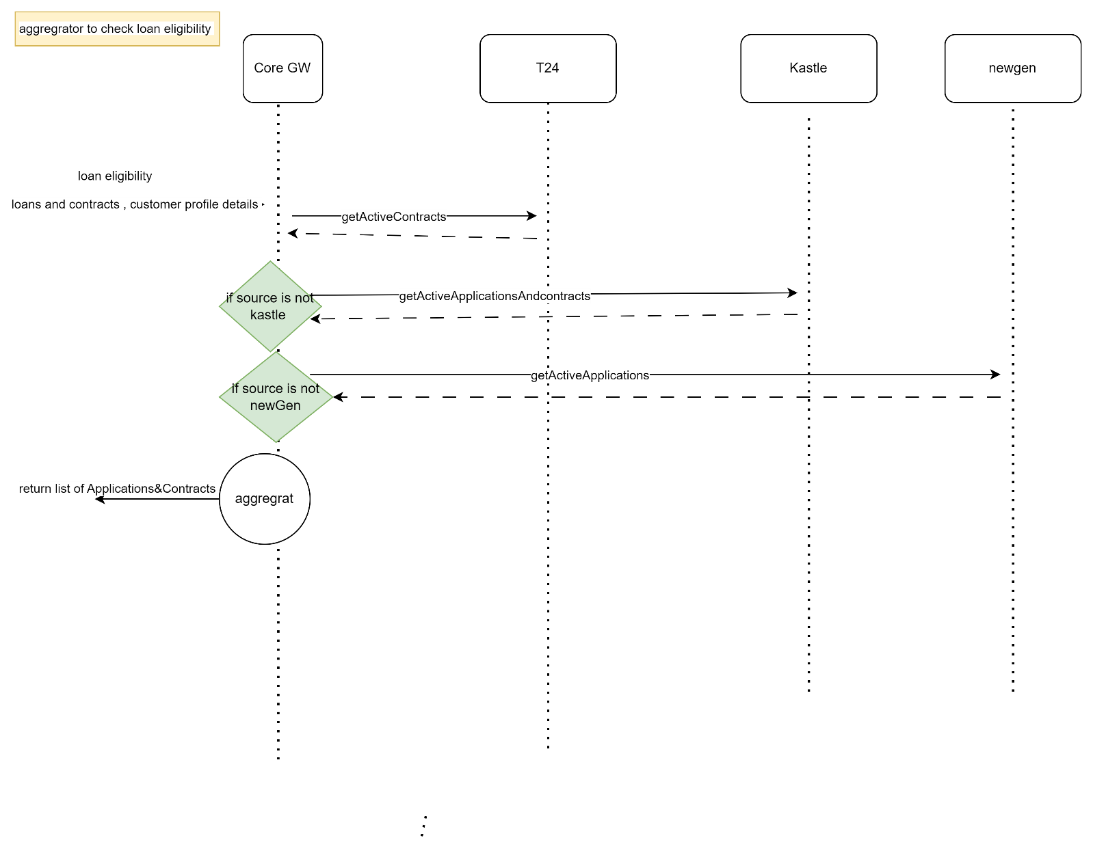

* Description

|  |  |  |  |  |  |
| --- | --- | --- | --- | --- | --- |
| **System Provider** | **Action** | **Request** | **Response** | **Type** | **Description** |
|  |  |  |  |  |  |

# Customer declaration

* Diagram

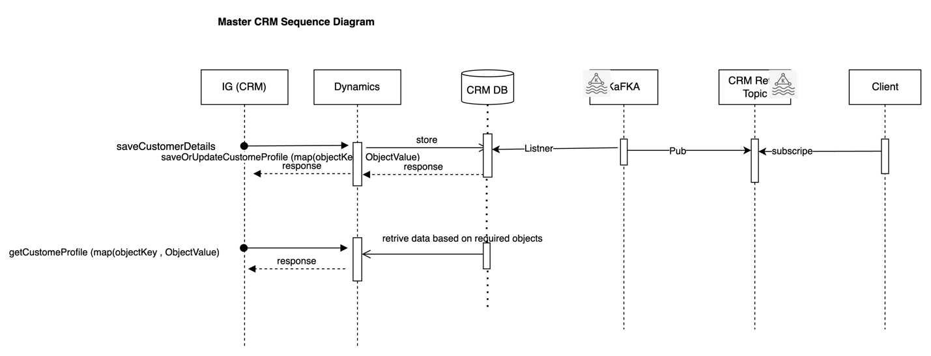

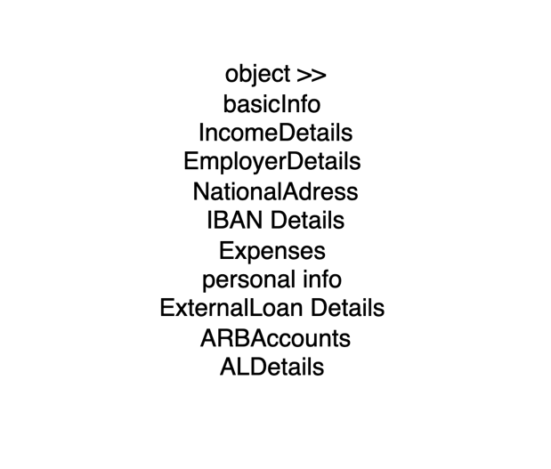

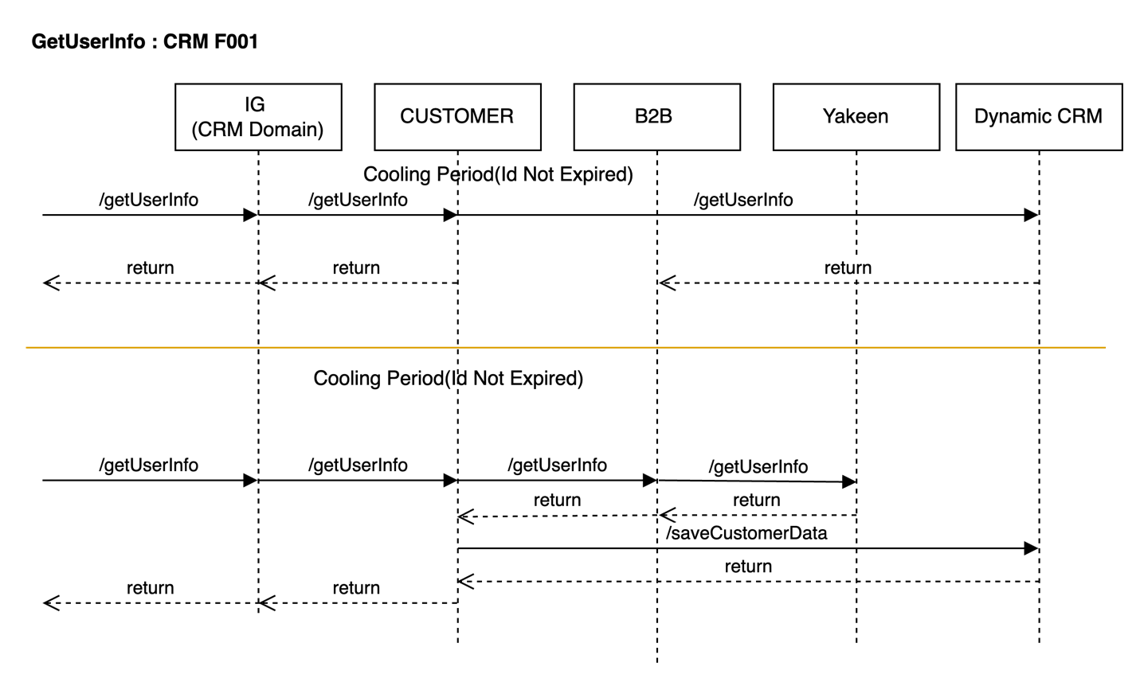

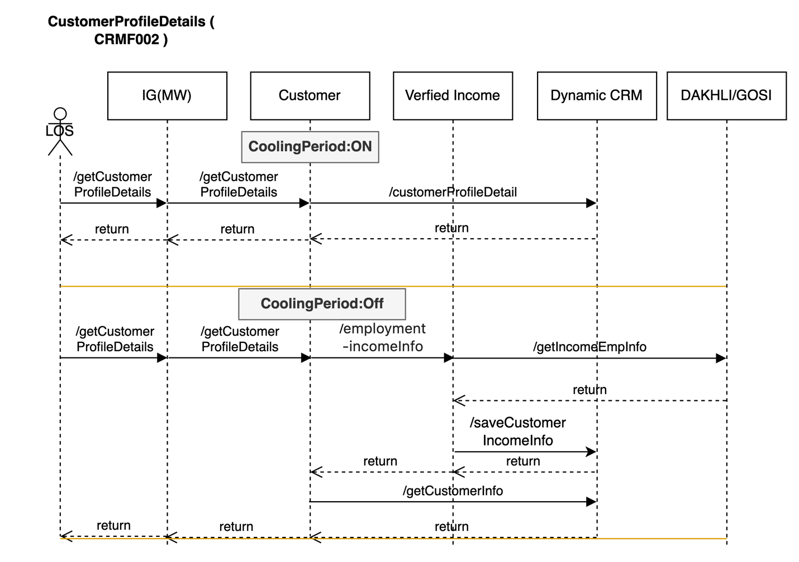

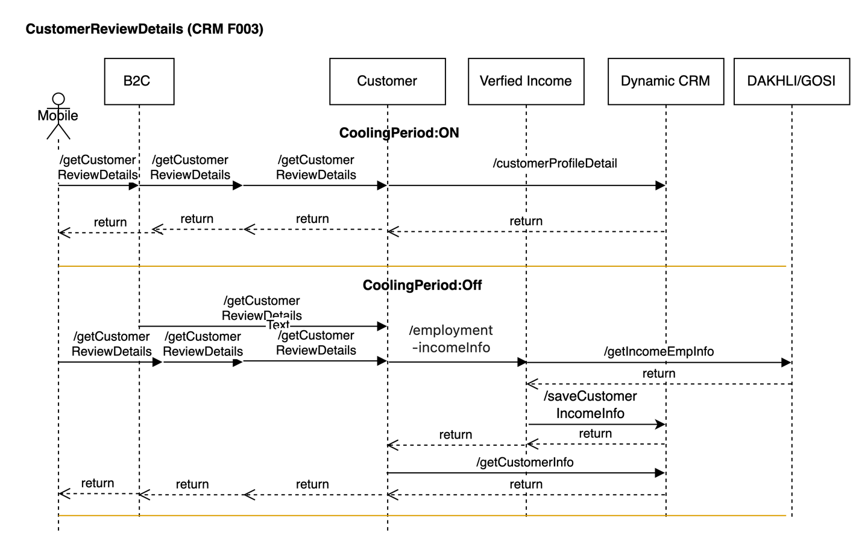

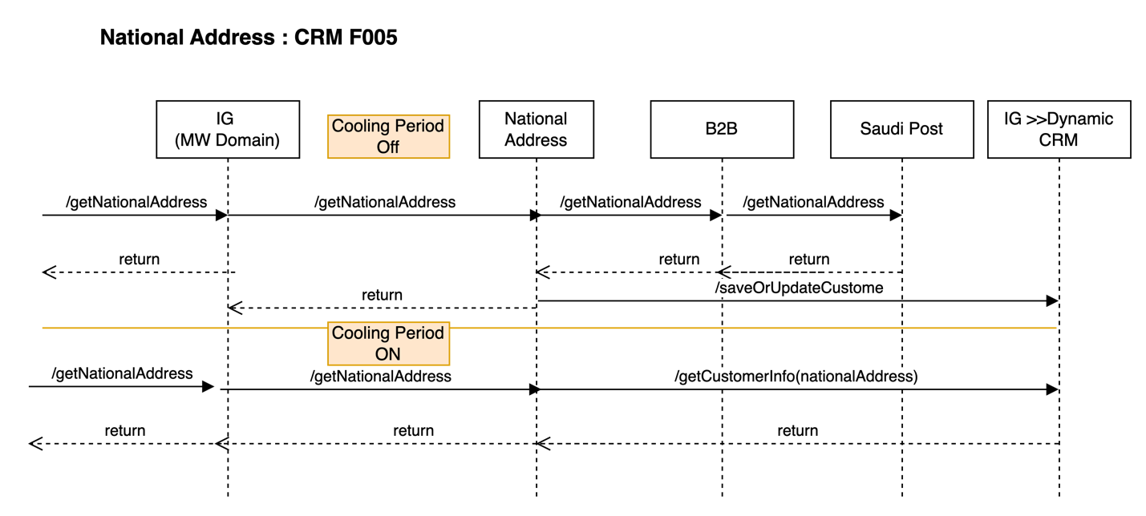

|  |  |  |  |  |  |
| --- | --- | --- | --- | --- | --- |
| **System Provider** | **Action** | **Request** | **Response** | **Type** | **Description** |
| **CRM** | /saveCustomerInfo |  |  |  | Refer IRD  CRM-EMK-DIG001  This api will be exposed by CRM to emkan. Emkan will call this api to save customer related information in Dynamic CRM.  Below objects will be passed as part of this request.  "basicCustInfo","addInfo","salInfo","expInfo","empInfo","autoLeaseCustomerInfo",ibanInfo","buyOutInfo","naInfo","companyInfo","loanDetails" |
| **CRM** | /getCustomerInfo |  |  |  | Refer IRD  CRM-EMK-DIG001  This api will be exposed by CRM to emkan. Emkan will call this api to get customer profile information from Dynamic CRM.  Below objects will be passed as part of this request to fetch customer profile.  "basicCustInfo","addInfo","salInfo","expInfo","empInfo","autoLeaseCustomerInfo","arbAccounts","ibanInfo","buyOutInfo","naInfo","companyInfo","loanDetails" |
| **CRM** | /saveCustomerInfo |  |  |  | Refer IRD  CRM-EMK-DIG001  This api will be exposed by CRM to emkan. Emkan will call this api to update customer profile information in Dynamic CRM.  Any object which need no update will be passed as null.  Below objects will be passed as part of this request to update customer information.  "basicCustInfo","addInfo","salInfo","expInfo","empInfo","autoLeaseCustomerInfo","arbAccounts","ibanInfo","buyOutInfo","naInfo","companyInfo","loanDetails" |
| **Kafka** | Kafka Topic | Request mentioned in  CRM-EMK-DIG003 |  | Kafka topic | When there is any update in CRM through api /SaveORUpdateCustomerInfo. KAFKA Will Listen to CRM DB to retrieve updated records and push updated data to Kafka topic and Ejada MW will listen to this topic and update other core system (LMS).  Below objects will be passed as part of this update request to update customer profile. And this objects will be pushed to Kafka topic.  "basicCustInfo","addInfo","salInfo","expInfo","empInfo","autoLeaseCustomerInfo","arbAccounts","ibanInfo","buyOutInfo","naInfo","companyInfo","loanDetails" |



**IRD for reference**

* Description

|  |  |  |  |  |  |
| --- | --- | --- | --- | --- | --- |
| **System Provider** | **Action** | **Request** | **Response** | **Type** | **Description** |
| Customer | /saveAdditionalInfo | asIs | asIs |  | This will internally calls /saveCustomerInfo with **additionalInfo object** in the request to save the information into CRM DB. |
| Customer | /saveIncome | asIs | asIs |  | This will internally calls /saveCustomerInfo with **salInfo object** in the request to save the information into CRM DB. |
| Customer | /getCustomerReviewDetails | asIs | asIs |  | This will internally calls /getCustomerInfo and it will fetch the information from CRM DB. |
| Customer | /saveExpenses | asIs | asIs |  | This will internally calls /saveCustomerInfo with **expInfo object** in the request to save the information into CRM DB. |
| Customer | /saveEmployment | asIs | asIs |  | This will internally calls /saveCustomerInfo with **employmentInfo object** in the request to save the information into CRM DB. |
| Customer | /getCustomerProfileDetails | asIs | asIs |  | This will internally calls /getCustomerInfo to fetch the information from CRM DB. |
| **CRM** | /getCustomerInfo |  |  |  | Refer IRD  CRM-EMK-DIG001  This api will be exposed by CRM to emkan. Emkan will call this api to get customer profile information from Dynamic CRM.  Below objects will be passed as part of this request to fetch customer profile.  "basicCustInfo","addInfo","salInfo","expInfo","empInfo","autoLeaseCustomerInfo","arbAccounts","ibanInfo","buyOutInfo","naInfo","companyInfo","loanDetails" |
| **CRM** | /saveCustomerInfo |  |  |  | Refer IRD  CRM-EMK-DIG001  This api will be exposed by CRM to emkan. Emkan will call this api to update customer profile information in Dynamic CRM.  Any object which need no update will be passed as null.  Below objects will be passed as part of this request to update customer information.  "basicCustInfo","addInfo","salInfo","expInfo","empInfo","autoLeaseCustomerInfo","arbAccounts","ibanInfo","buyOutInfo","naInfo","companyInfo","loanDetails" |

# product Eligibility check

* Diagram

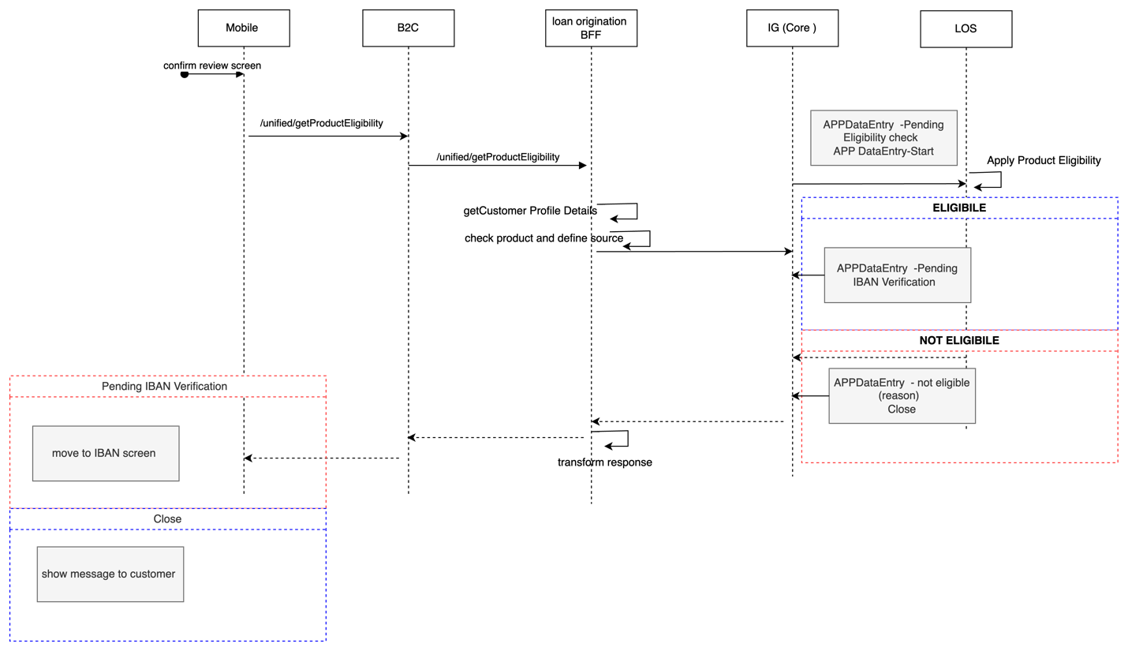

* Description

|  |  |  |  |  |  |
| --- | --- | --- | --- | --- | --- |
| **System Provider** | **Action** | **Request** | **Response** | **Type** | **Description** |
|  |  |  |  |  |  |

1. Description

# IBAN Verification

Design Overview

* Diagram

TBD

* Description

# Upload Document Flow

Design Overview

* Diagram

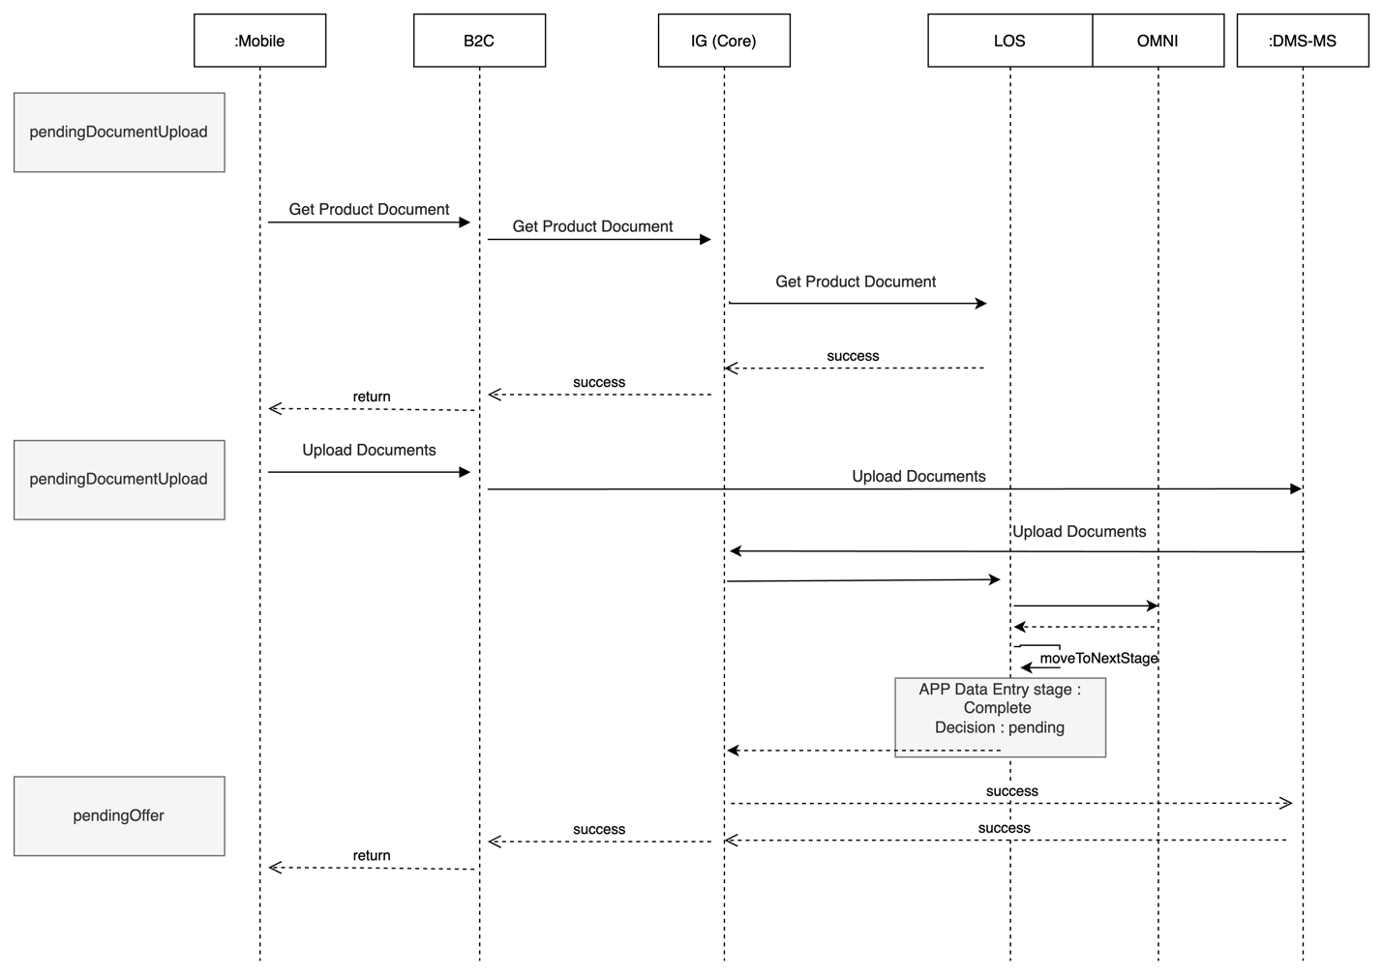

* Description

|  |  |  |  |  |  |
| --- | --- | --- | --- | --- | --- |
| **System Provider** | **Action** | **Request** | **Response** | **Type** | **Description** |
|  |  |  |  |  |  |

# **Deployment and Security View**

TBD

# 

# Appendix A - Architectural Decisions

|  |  |  |  |
| --- | --- | --- | --- |
| Subject Area |  |  |  |
| Architectural Decision |  |  |  |
| Issue or Problem Statement |  | | |
| Assumptions |  | | |
| Motivation |  | | |
| Alternatives |  | | |
| Decision |  | | |
| Justification |  | | |
| Implications |  | | |
| Derived requirements |  | | |
| Related Decisions |  | | |

|  |  |  |  |
| --- | --- | --- | --- |
| Subject Area |  |  |  |
| Architectural Decision |  |  |  |
| Issue or Problem Statement |  | | |
| Assumptions |  | | |
| Motivation |  | | |
| Alternatives |  | | |
| Decision |  | | |
| Justification |  | | |
| Implications |  | | |
| Derived requirements |  | | |
| Related Decisions |  | | |

# Appendix D – Failing Retry Policy

|  |  |  |  |  |
| --- | --- | --- | --- | --- |
| **System** | **Error Code** | **Retry Mechanism** | **Max Number of Retry** | **Alternative after Pass Max No of Retry** |
| Emkan Services | Not http “200” | Exponential back off  Starting with interval 5 mins | 20 | Create Jira ticket |
| “Newgen”,MW | Not http “200” | Retry every 10 min | 20 | Create Jira ticket |

# Appendix E – Cooling Period

|  |  |  |
| --- | --- | --- |
| **Stage/Type** | **Cooling Period** | **System Owner** |
| IVR |  |  |
| signing contract | 24 h |  |
| generate Sanad |  |  |
| Sanad approval | 24 h |  |
| commodity sales maker | 24 h |  |
| commodity delivery |  |  |
| document custody |  |  |

# Appendix R – Risks

|  |  |  |
| --- | --- | --- |
| **Stage/Type** | **Risk** |  |
|  |  |  |
|  |  |  |
|  |  |  |

# Appendix I – General Impacts

|  |  |  |
| --- | --- | --- |
| **owner** | **stage** | **impact** |
| MW |  |  |
|  |  |  |
|  |  |  |